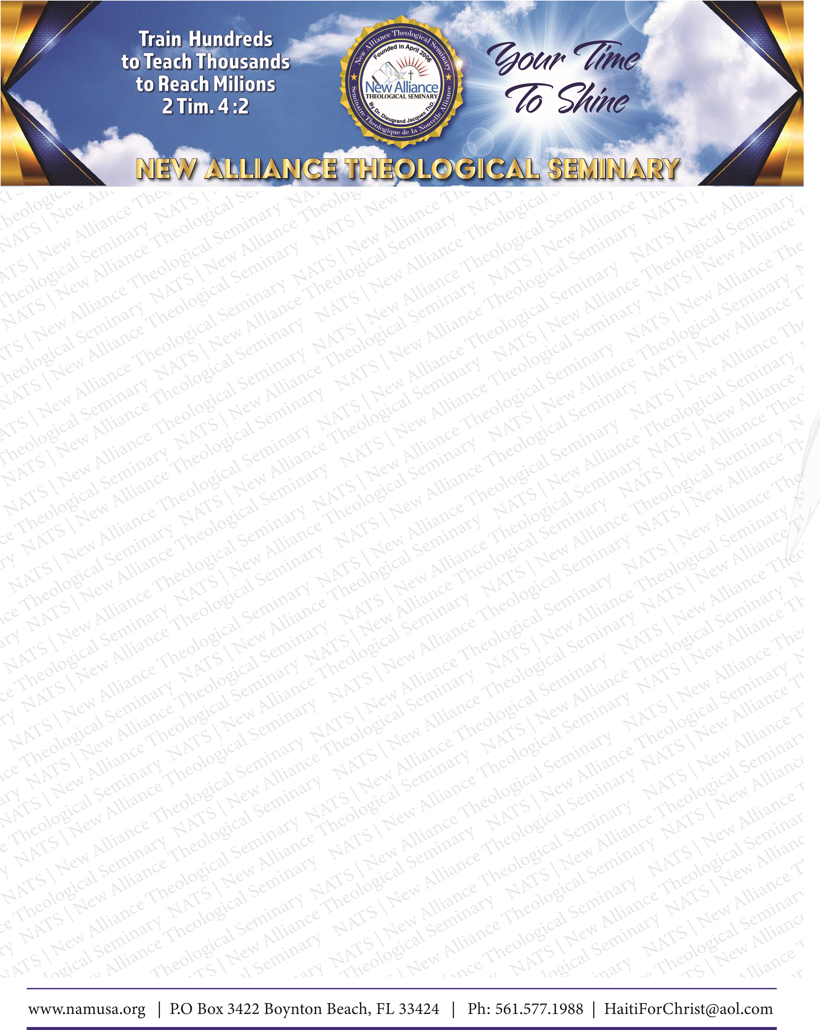
N
STUDENT’S OFFICIAL TRANSCRIPT
STUDENT: Isaiah Joshua Watts STUDENT ID : xxx-xx-0861/X94241 DOB :04/09/1996
DEGREE: Associate of Ministry MAJOR: Biblical Studies GRADUATE: Nov. 2022

COURSE # | COURSE NAME | COMPLETION DATE | FINAL GRADE | CREDITS
NA01BA | SPIRITUAL LEADERSHIP | x2019 | 81/B | 3 CEU
NA02BA | ECCLESIOLOGY | x | 92/A | 3 CEU
NA03BA | BIBLICAL APOLOGETICS | x | 91/A | 3 CEU
NA04BA | CHRISTIAN TEACHING | x | 80/B | 3 CEU
NA05BA | BIBLICAL DOCTRINES | x2020 | 87/B | 3 CEU
NA06BA | BIBLICAL ESCHATOLOGY | x | 84/B | 3 CEU
NA07BA | CHURCH ADMINISTRATION | x | 94/A | 3 CEU
NA08BA | BIBLICAL ETHICS | x | 76/C | 3 CEU
NA09BA | CHRISTIAN EDUCATION | x2021 | 94/A | 3 CEU
NA10BA | CHRISTIAN CRISIS COUNSELING | x | 86/B | 3 CEU
NA11BA | SYSTEMATIC THEOLOGY 1 | x | 81/B | 3 CEU
NA12BA | SYSTEMATIC THEOLOGY 2 | x | 91/A | 3 CEU
NA13BA | WORLD RELIGIONS | X2021 | 92/A | 3 CEU
NA14BA | BIBLICAL COUNSELING | x | 95/A | 3 CEU
NA15BA | EDUCATIONAL PSYCHOLOGY | x | 94/A | 3 CEU
TOTAL CREDITS: 45 TOTAL GPA: 3.9
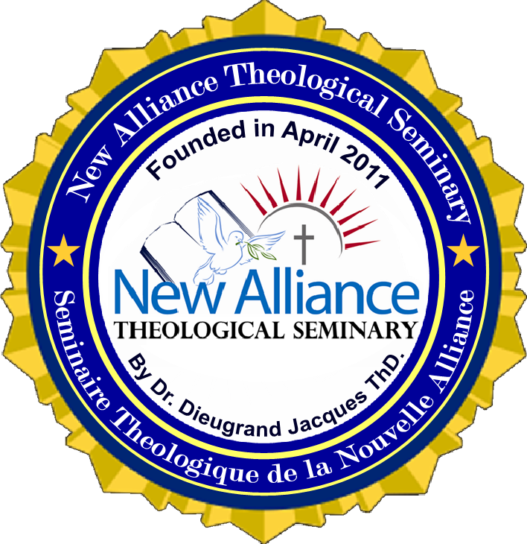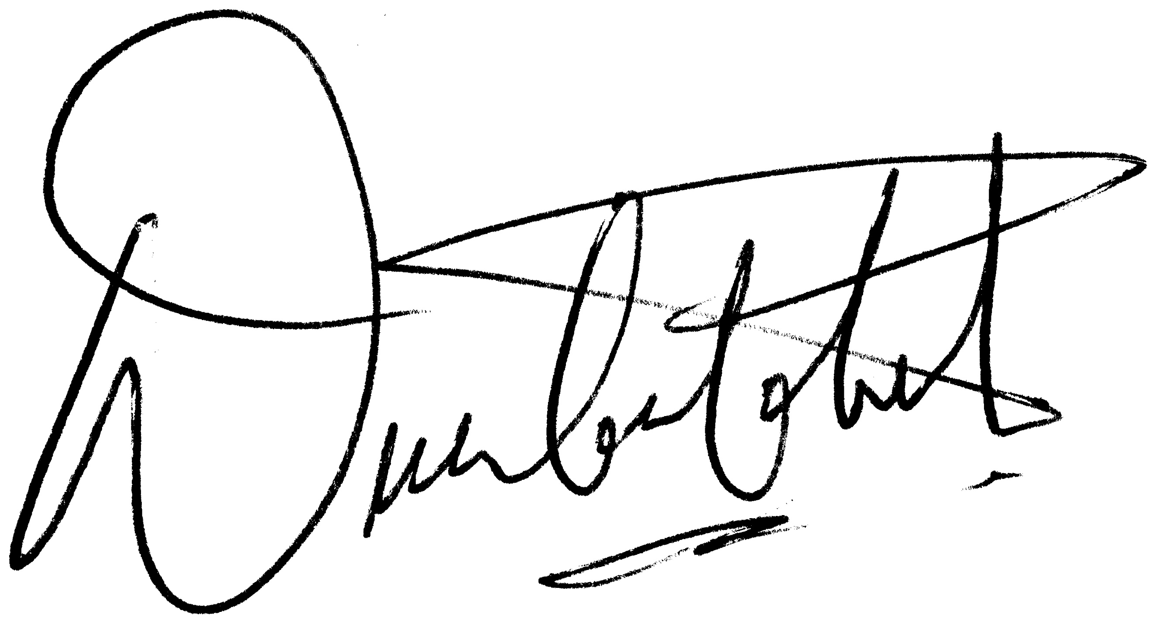
DR. DIEUGRAND JACQUES, PHD, THD

NOT OFFICIAL UNLESS SIGNED BY THE PRESIDENT.
THE NAME OF THE SEMINARY IS PRINTED IN WHITE ACROSS THE FACE OF THIS 8 ½ X 11 DOCUMENT.

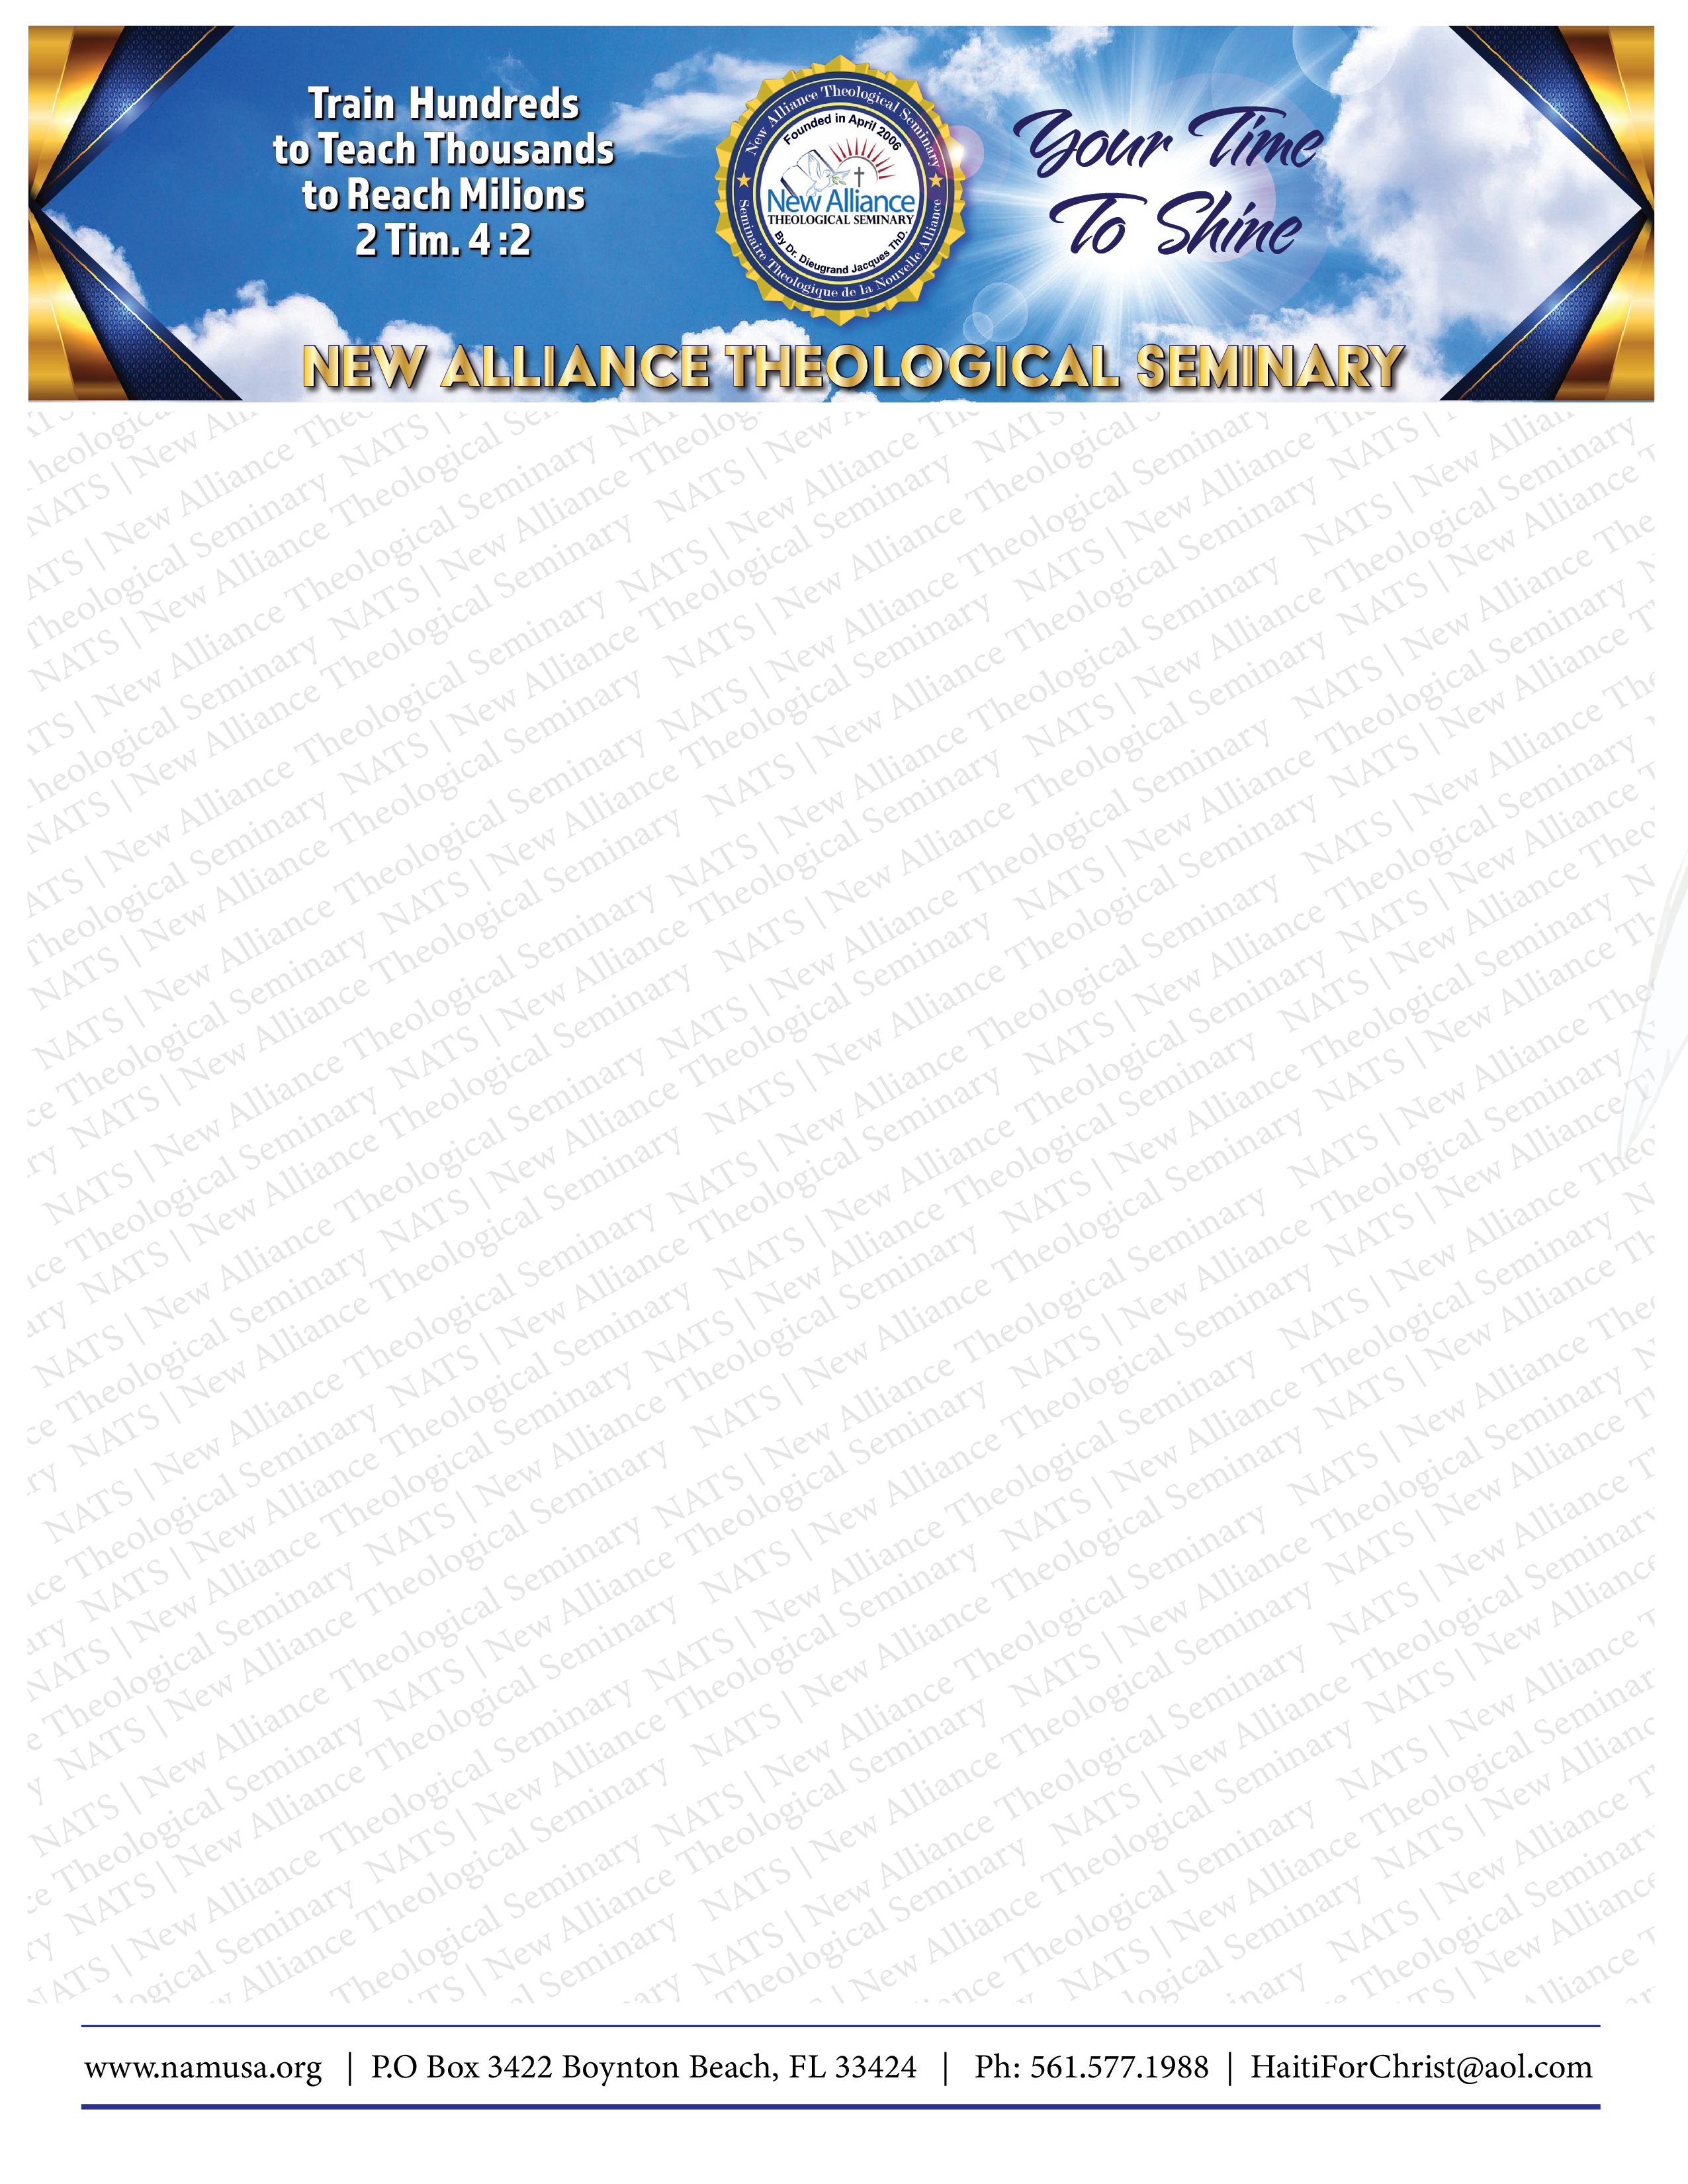

Date Requested 10/30/2022

